|  |
| --- |
| Assignment-internetworking security |
|  |
| +_+ |

Contents

Introduction about the website: 1

Part 1: Website and Web Server Setup 2

Part 2: Implement Access Control Feature 10

Part 3: Firewall Configuration Using iptables 12

Part 4: Server Monitoring with Nagios or RABBIX 17

Task 5: Website Security Testing – SQL Injection & Forced Browsing 20

Task 6: Accessing the Website from Another Virtual Machine 22

Conclusion 24

# Introduction about the website:

This project involves setting up a personal portfolio website on a virtual machine running Ubuntu. The website includes a login system and blog functionality, using a MySQL database to store user and blog data. The main goal is to deploy the site securely, then simulate and test common cybersecurity attacks such as SQL injection, brute-force login attempts, and unauthorized access to admin pages. This helps in understanding how vulnerabilities can be exploited and how to defend against them using secure coding practices and tools like firewalls (iptables).

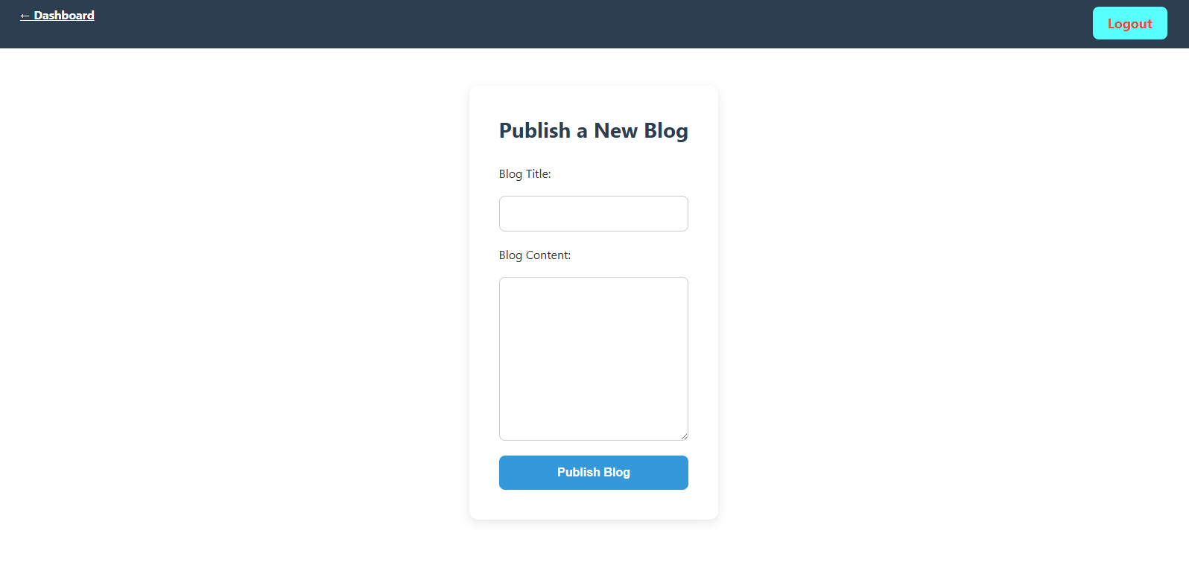

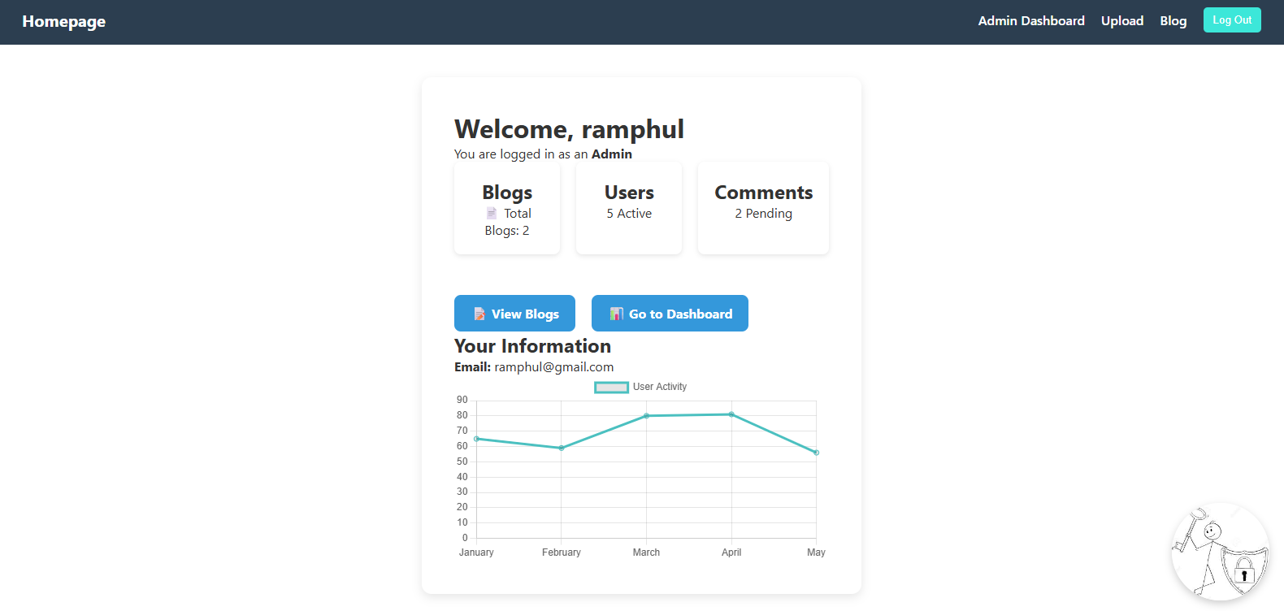

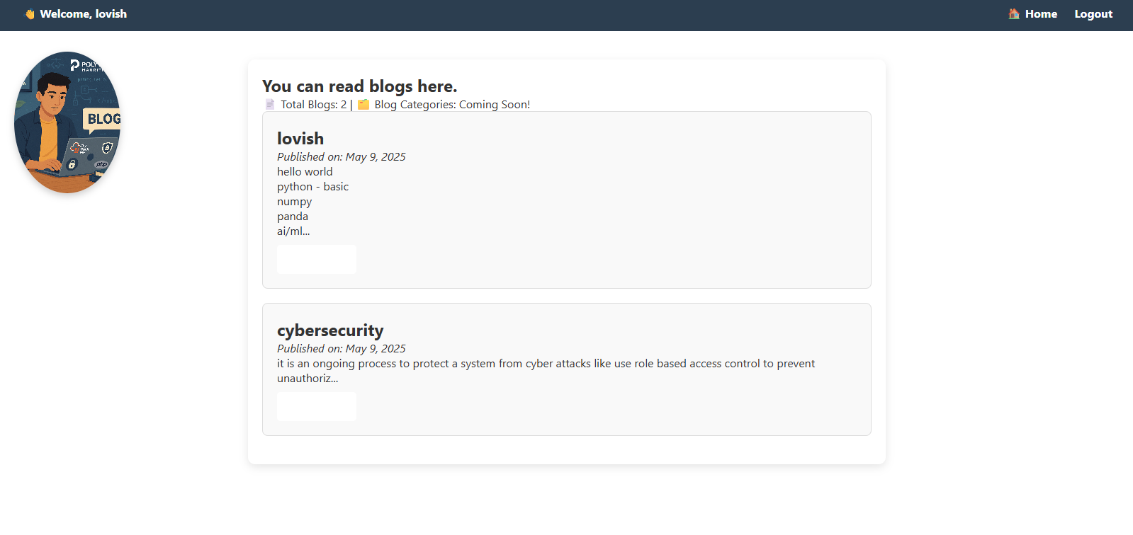



This is our website.

# Part 1: Website and Web Server Setup

**Installing Apache, MySQL, PHP, PHP-MySQL Extension & phpMyAdmin**

To prepare the server environment for hosting the portfolio website, I installed the full LAMP stack on Ubuntu using the apt package manager. This included:

* **Apache Web Server** – to serve web pages
* **MySQL Server** – to store user and blog data
* **PHP & PHP-MySQL Extension** – to process dynamic content and connect to the database
* **phpMyAdmin** – for managing MySQL databases through a web interface

,,,,,,,,,,,,,,,,,,,,,,,,,,,,,,,,,,,,,,,,,,,,,,,,,,,,,,,,,,,,,,,,,,,,,,,,,,,,

Step 1: Update and Upgrade System Packages

Before installing any software, I made sure the system's package list and installed packages were up to date.

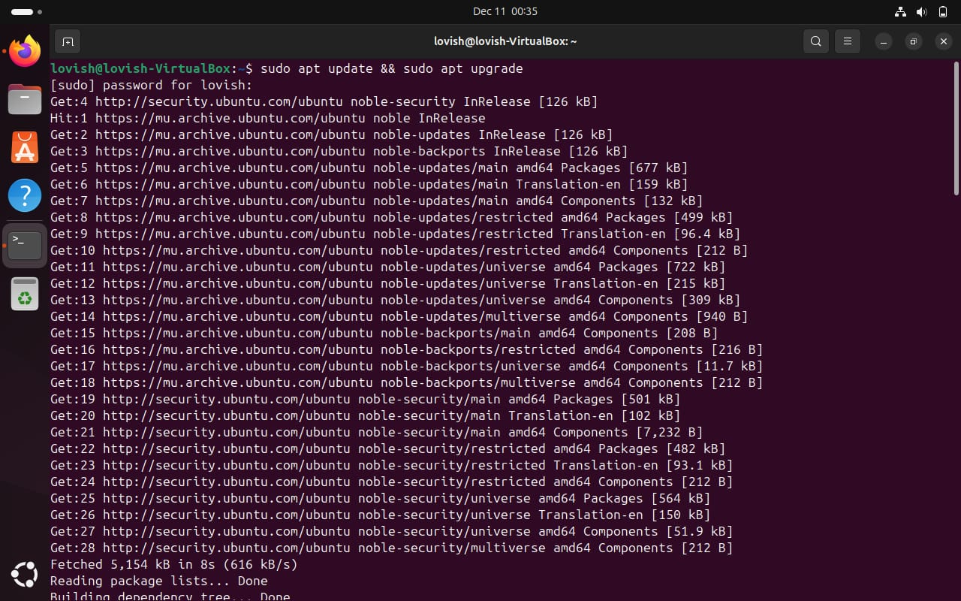

**Explanation:**

* sudo apt update:  
  This command updates the list of available packages and versions from the Ubuntu repositories. It does **not install** or upgrade any packages — it just refreshes the list.
* sudo apt upgrade:  
  This command installs the **newest versions** of all packages that are currently installed on the system. It upgrades the software to make sure everything is up to date and secure.

*📸 Figure 1: Running sudo apt update && sudo apt upgrade to update the system.*

**Step 2: Install Apache Web Server**

Apache is the software that serves the website over the internet.

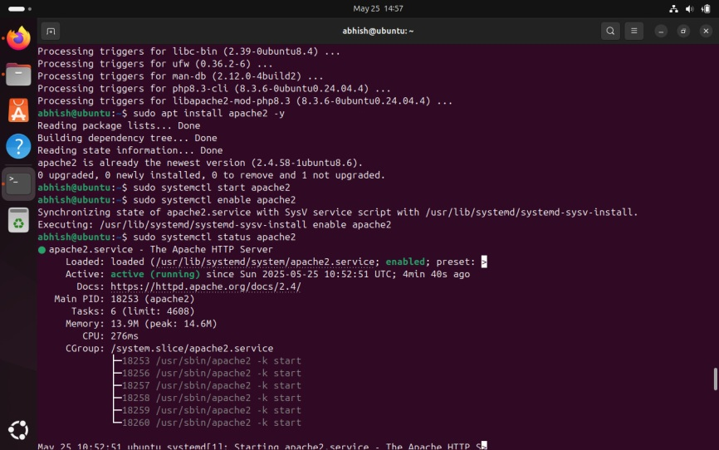

* apache2: The Apache web server package.
* -y: Automatically confirms the installation.

📸 *Figure 2: Apache installed successfully.*

**Step 3: Install MySQL Server**

**MySQL is the database system used to store website data like users and blogs.**

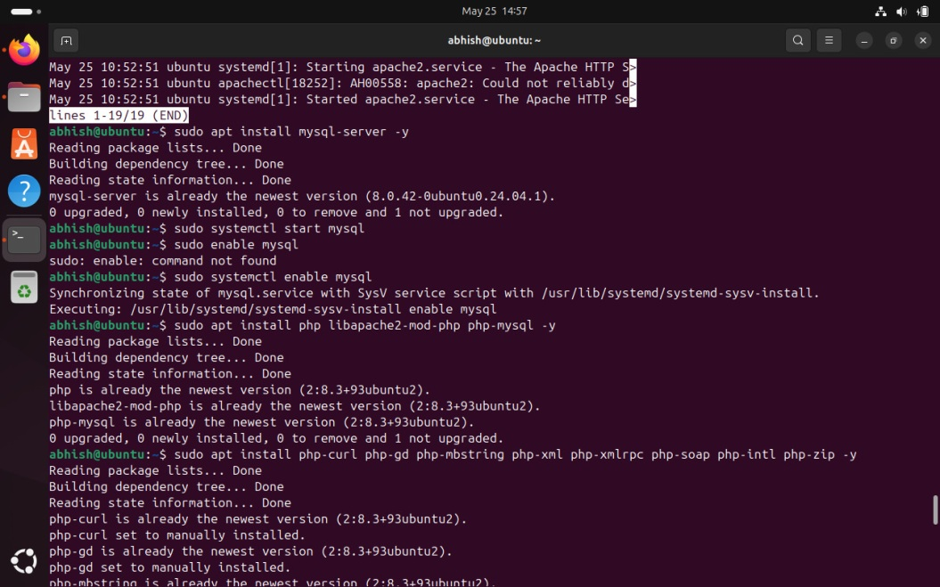

* Installs the MySQL database server.

📸 *Figure 4: MySQL server installation completed.*

**Step 4: Install PHP**

PHP is a programming language used to create dynamic web pages.

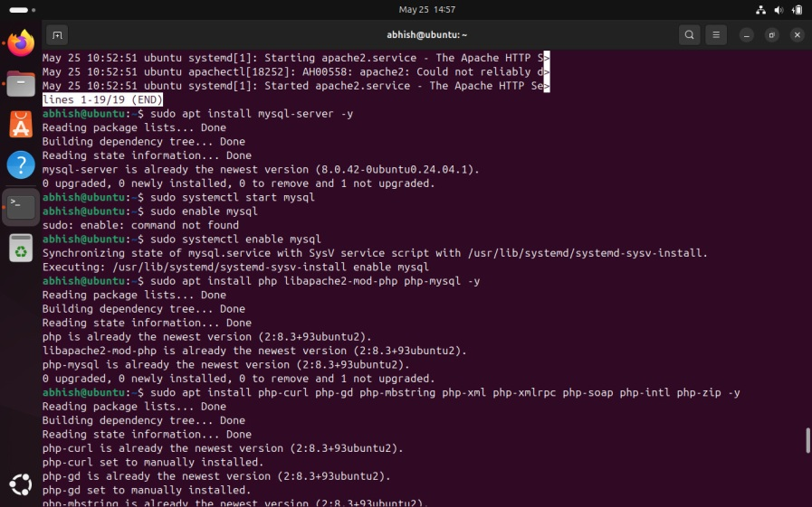

* php: Installs the core PHP package.
* libapache2-mod-php: Allows Apache to run PHP files.

**Step 5: Install PHP-MySQL Extension**

This package allows PHP to connect and communicate with MySQL databases.

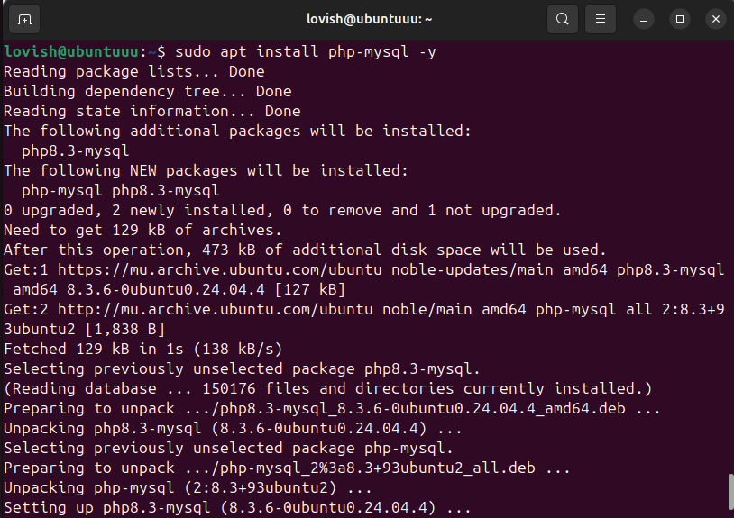

📸 *Figure 5: PHP-MySQL module installed to connect PHP with MySQL*

**Step 6: Install phpMyAdmin**

phpMyAdmin is a web-based interface to manage MySQL databases easily.



📸 *Figure 6: phpMyAdmin installed.*

**Step 7: Secure the MySQL Root User**

I logged into MySQL and changed the root password for security and phpMyAdmin compatibility.

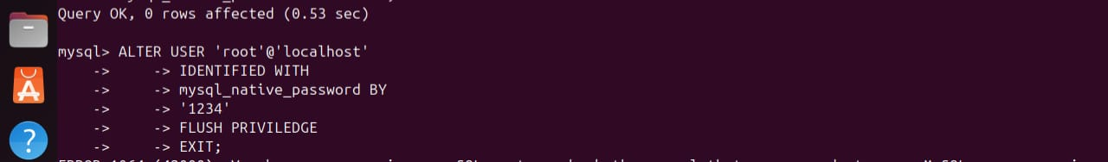

📸 *Figure 7: MySQL root user secured with native password.*

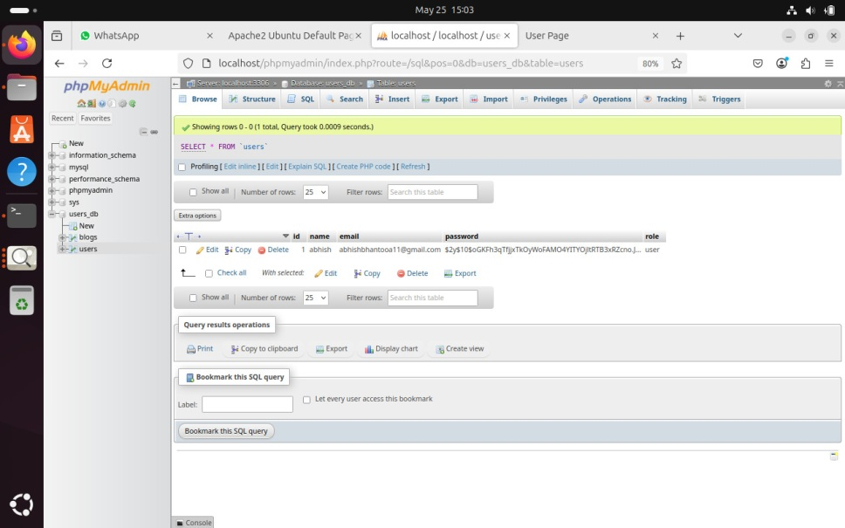

*Figure 8: Database*

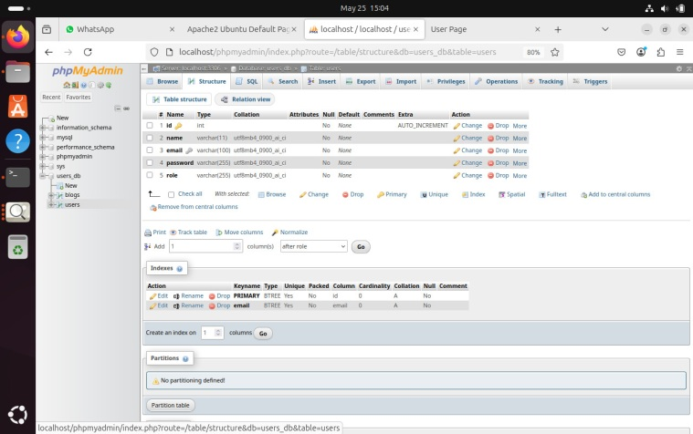

Users table

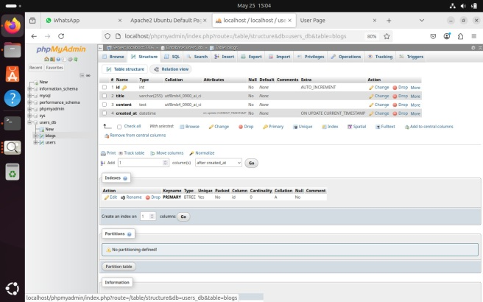

Blogs table

**Moving Website to Apache Directory and Setting Permissions**

After developing the portfolio website, I moved the project folder to Apache’s default web directory:  
/var/www/html/.

To ensure the server could access and serve the website files securely, I set the correct ownership and permissions:

* Used sudo chown -R www-data:www-data to give ownership to Apache
* Applied sudo chmod -R 755 to allow read and execute access

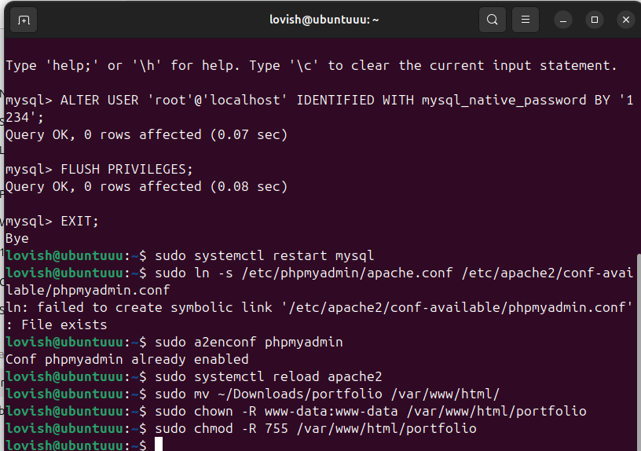

**Step 11: Reload Apache to Apply Changes**

After setting the correct file ownership and permissions, I reloaded Apache to apply any changes without interrupting ongoing connections.

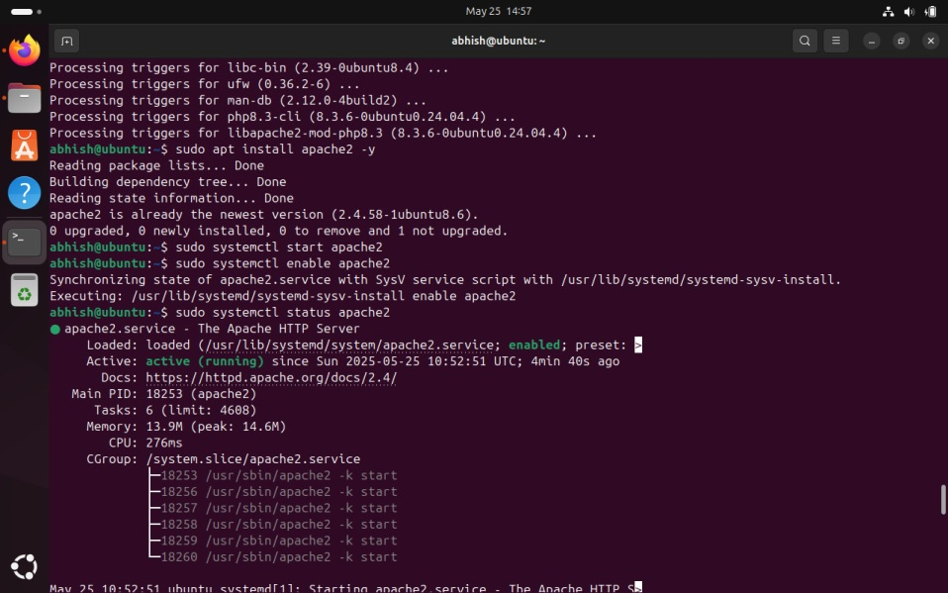

* **sudo systemctl**: Manages system services (like Apache).
* **reload apache2**: Reloads Apache configuration and updates the file structure changes (like new folders or permissions) **without stopping the server**.

Reloading is a safe way to apply changes without downtime.

**Figure 11**: Apache server reloaded to apply updated ownership and permissions for the portfolio site.

**Step 12: Website Access**

**Portfolio Site**:  
<http://192.168.100.197/portfolio>



**phpMyAdmin Interface**:  
<http://192.168.100.197/phpmyadmin>

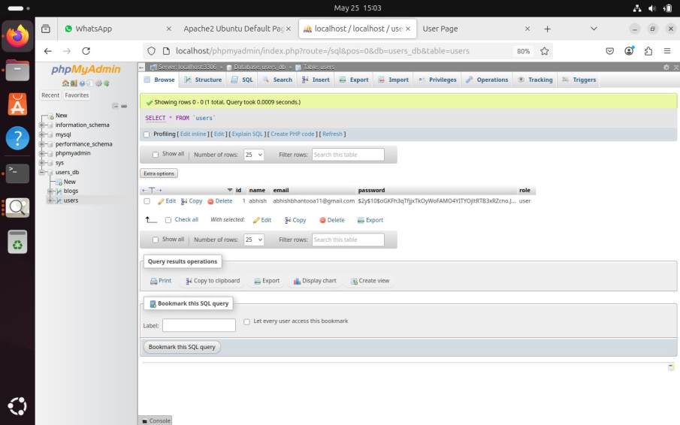

# Part 2: Implement Access Control Feature

**Implement Role-Based Access Control (RBAC)**

To ensure that users only access content they're authorized for, I implemented **Role-Based Access Control (RBAC)** using PHP. Each user is assigned a role during registration, and upon login, the user is redirected to a different page depending on their role.

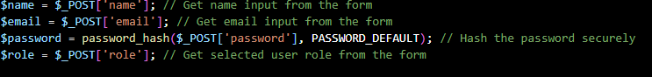

✅ When a user registers, their role (admin or user) is saved in the database.

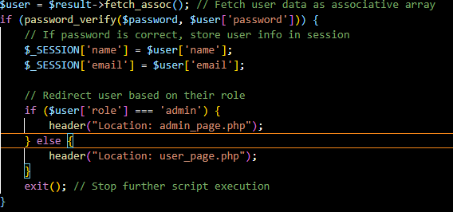

After login:

* **Admins** are redirected to admin_page.php



* **Regular users** are redirected to user_page.php



# 

# Part 3: Firewall Configuration Using iptables

To secure the server, I configured the firewall using iptables. The goal was to **restrict incoming traffic** and only allow essential services such as HTTP (port 80), HTTPS (port 443), and SSH (port 22) from a specific IP address.

**🔹 Step 1: Update and Upgrade System Packages**

Before making firewall changes, I ensured the system was up to date.

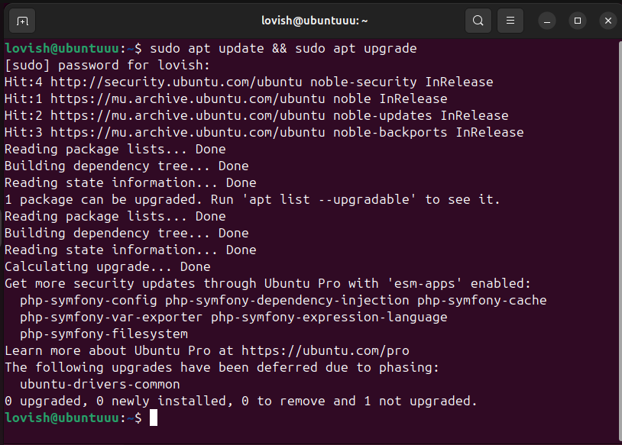

• sudo apt update: Updates the list of available packages.

• sudo apt upgrade: Installs the latest versions of all installed packages.

**Step 2: Flush Existing iptables Rules**

Cleared all existing firewall rules to start with a clean configuration.

**Step 3: Set Default Policies**

Configured the default iptables behavior to **deny incoming and forwarded traffic** but **allow outgoing** connections.

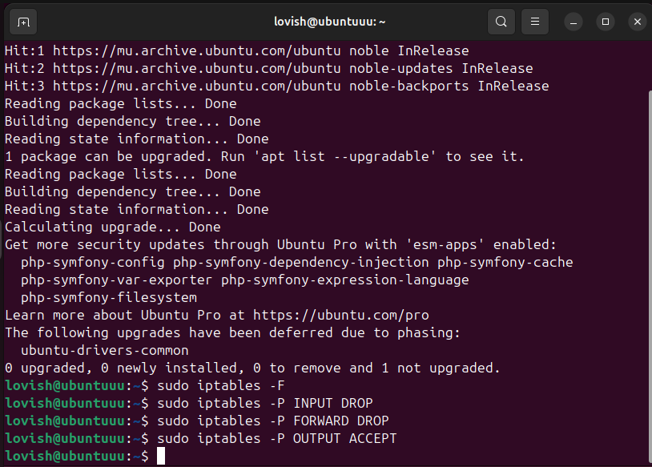

* INPUT DROP: Deny all incoming traffic by default.
* FORWARD DROP: Deny forwarding traffic.
* OUTPUT ACCEPT: Allow all outgoing connections.

Step 4: Allow Localhost (Loopback) Access

Enabled internal communications on the system.

**Step 5: Allow Established and Related Connections**

Permits return traffic from outgoing connections and connections related to already established sessions.

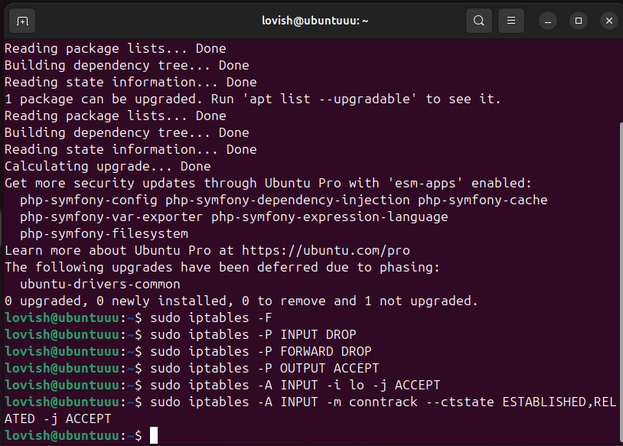

* -i lo: Targets the loopback interface (127.0.0.1).
* -j ACCEPT: Allows the traffic.
* Uses conntrack module to allow traffic that's part of an existing or related connection.

Step 6: Allow HTTP Traffic (Port 80)

Allows access to the web server via HTTP.

**Step 7: Allow HTTPS Traffic (Port 443)**

Allows encrypted traffic (HTTPS) to reach the web server.

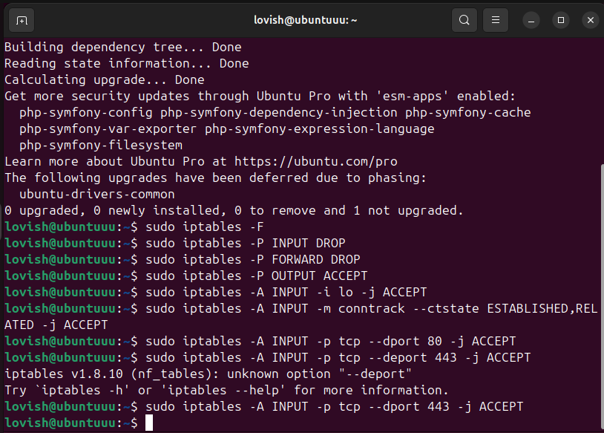

* --dport 80: Targets TCP traffic on port 80.
* --dport 443: Targets TCP traffic on port 443.

**Step 8: Allow SSH Access From Specific IP**

Restricts SSH access to only one trusted IP address.

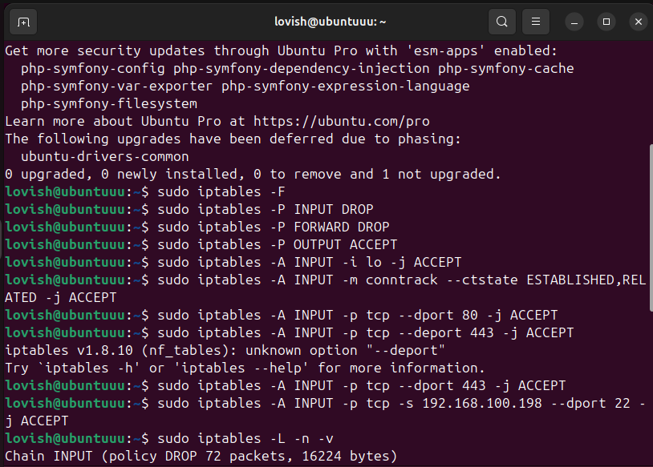

* -s 192.168.100.198: Only allows SSH from this IP address.
* --dport 22: SSH port.

**Step 9: View Current Firewall Rules**

To confirm the firewall rules are set correctly, I listed them.

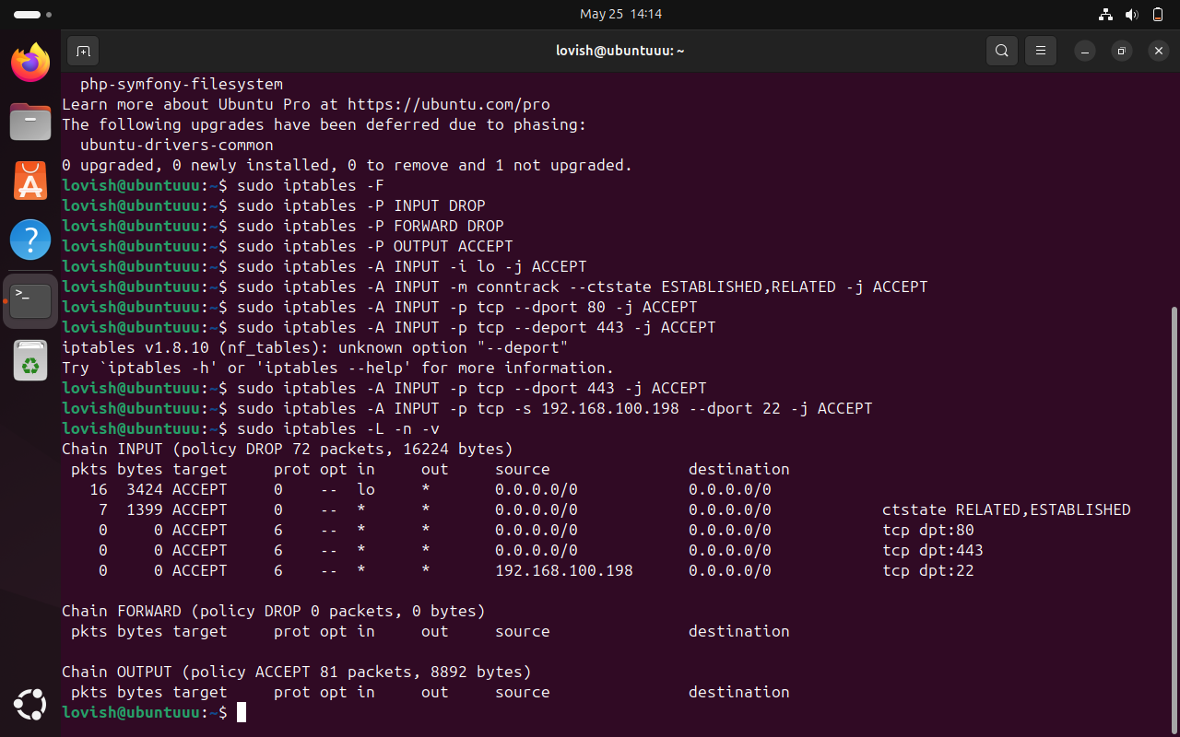

* -L: Lists all rules.
* -n: Shows numeric values (no DNS).
* -v: Verbose output.

**Step 10: Save iptables Rules**

Ensures the iptables configuration is preserved after a system reboot.

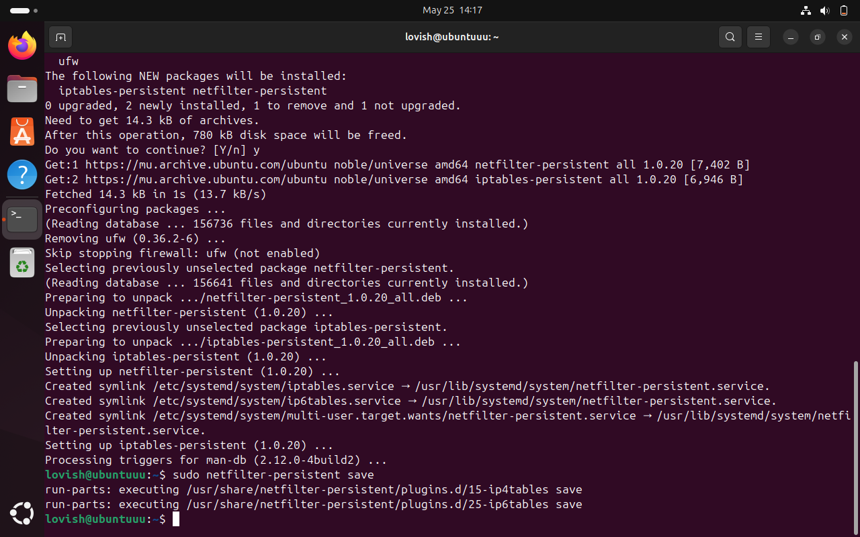

* Saves current iptables rules using the netfilter-persistent service.

# Part 4: Server Monitoring with Nagios or RABBIX

**Installation of Zabbix Agent**

To monitor the website server, I installed the Zabbix agent, which collects system and service data and sends it to the Zabbix monitoring server.

The installation was done using the following commands on the web server:

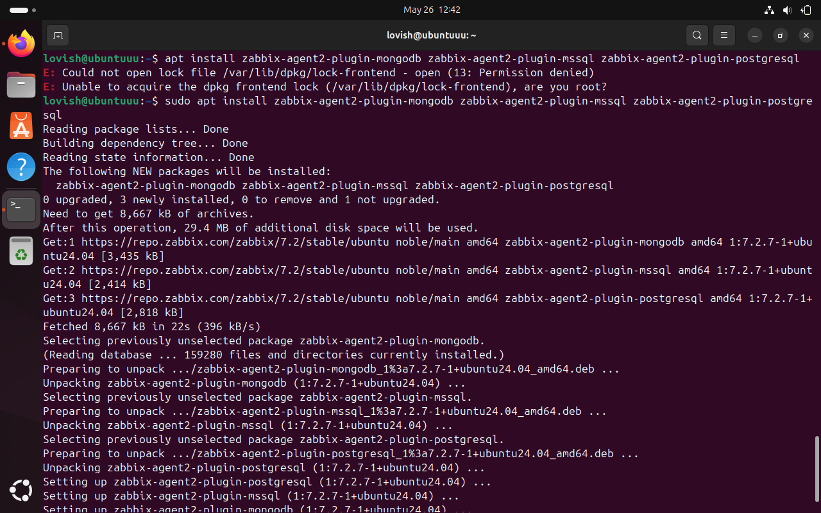

**Zabbix Monitoring Dashboard**

This screenshot displays the Zabbix dashboard monitoring the web server. It visualizes important performance metrics and the status of services to ensure the website remains available and responsive.

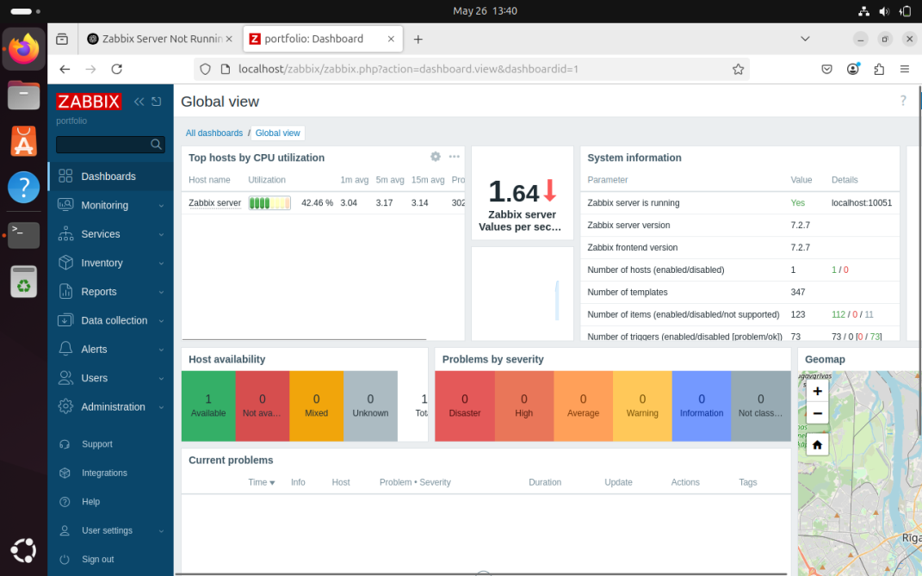

**Linking Zabbix Agent to Monitor the Website Server**

This screenshot shows the configuration of the Zabbix agent on the web server. The agent is responsible for collecting server performance data and sending it to the Zabbix monitoring server, enabling continuous monitoring of the website’s health.

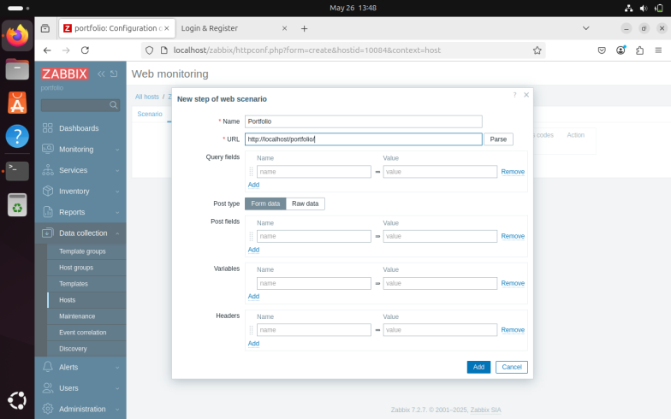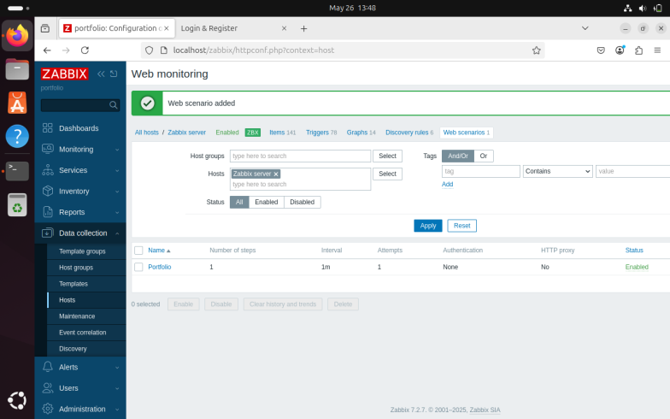

**Creating a Trigger to Monitor Website Uptime**

This screenshot shows the setup of a trigger in Zabbix to monitor the website’s HTTP response status.

* The trigger checks if the website returns a **200 OK** status, indicating the site is up and functioning correctly.
* If the response changes to **404 Not Found** or any other error status, the trigger activates an alert.

This helps to quickly detect when the website is down or unreachable, ensuring prompt action can be taken to restore service.

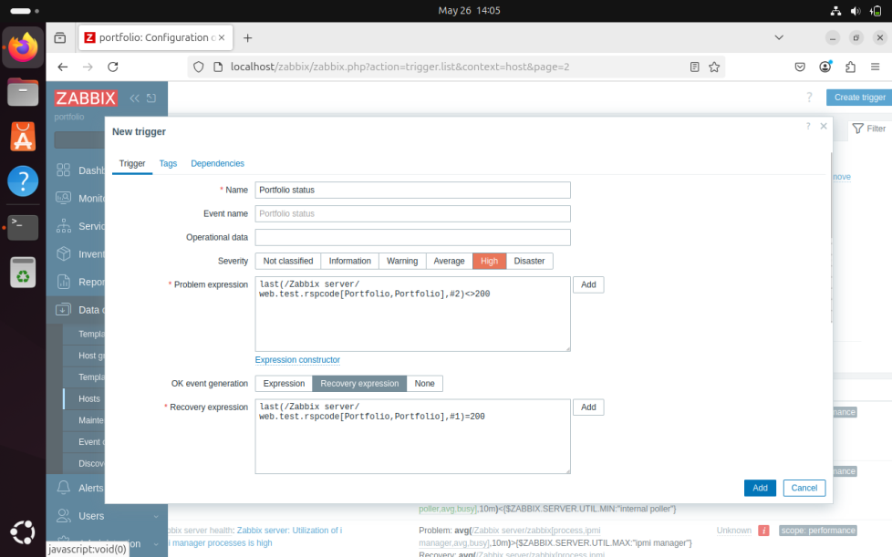

**Trigger for CPU Load and RAM Usage**

This screenshot shows the configuration of a combined trigger monitoring both CPU load and RAM usage on the server.

* The trigger monitors the **average system load** and **memory consumption** to detect when the server is under heavy resource usage.
* If the CPU load or RAM usage exceeds the defined thresholds (e.g., CPU load above 80%, RAM usage above 75%), the trigger activates an alert.
* This combined monitoring helps ensure the server remains responsive and prevents performance degradation due to resource exhaustion

……………..

**Setting Up Email Alerts for Critical Events**

To ensure timely responses to critical server and website issues, email alerts were configured in Zabbix for the following conditions:

* **Website Downtime:** An email notification is sent whenever the website trigger detects downtime, such as receiving a 404 error or no response, enabling immediate investigation and resolution.
* **High CPU/Memory/Disk Usage:** Alerts are triggered and emailed when server resources exceed predefined thresholds (e.g., CPU load over 80%, memory usage above 75%, or disk usage reaching critical levels), helping to prevent performance degradation or system failure.

This alert system allows administrators to proactively monitor server health and maintain website availability by responding quickly to issues as they arise.

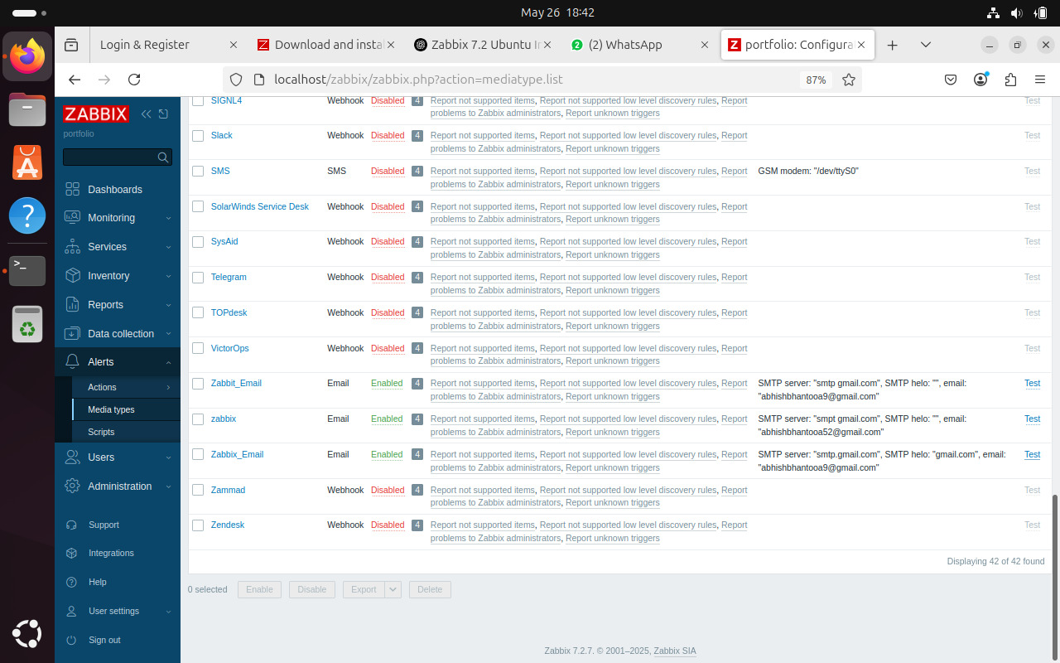

# Task 5: Website Security Testing – SQL Injection & Forced Browsing

To verify the security of my deployed website, I performed basic **attack simulations** such as **SQL injection** and **forced browsing**. These tests were unsuccessful, confirming that the website had some level of defense mechanisms in place.

**Step 1: SQL Injection Protection via Prepared Statements**

In the login and registration process, I implemented **prepared statements** to prevent SQL injection.

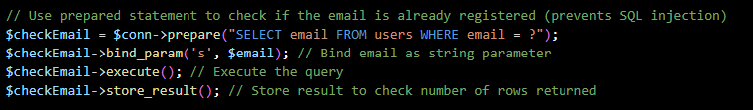

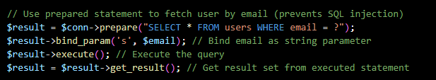

**Explanation:**

* **Prepared statements** prevent direct injection of SQL code into the query.
* Inputs are **bound** separately from the SQL logic, protecting against attackers trying to bypass authentication or manipulate the database using strings like admin' OR '1'='1.

Step 2: Simulated SQL Injection Attack (Unsuccessful)

I attempted a SQL injection through the login form using inputs like:

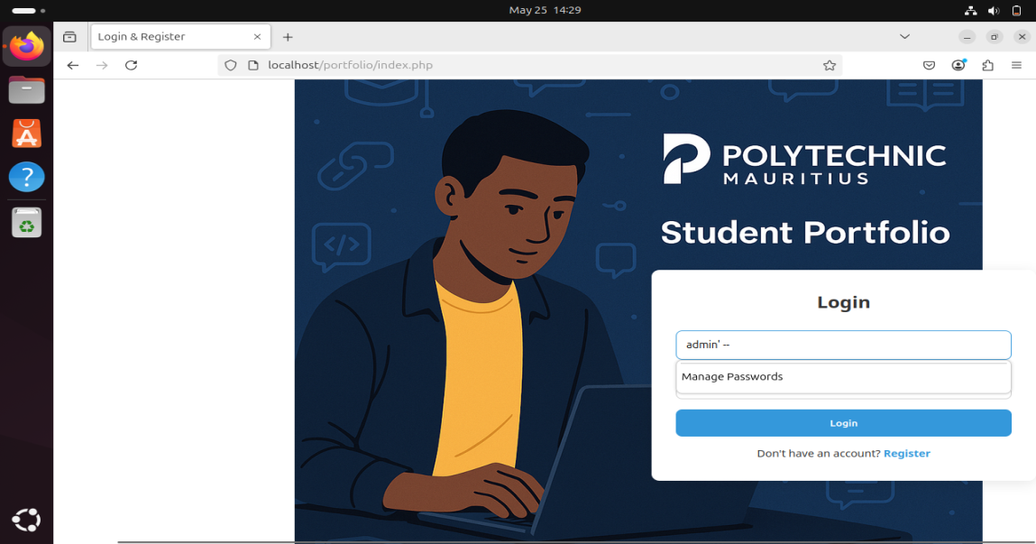

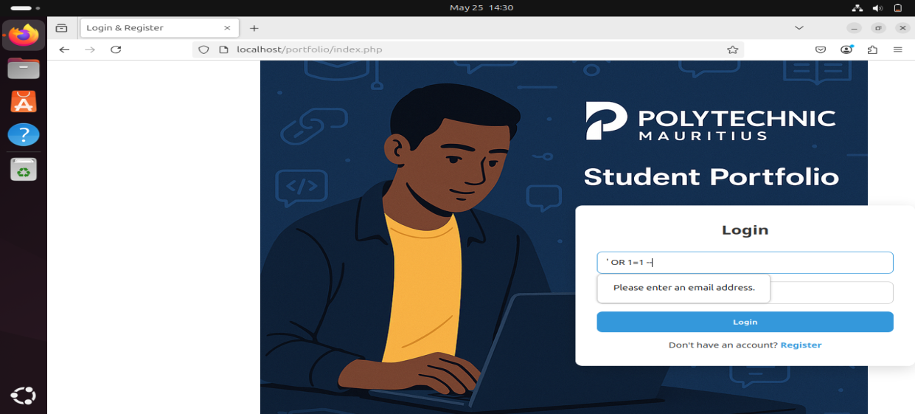

**Result: Login failed** – due to secure query execution using prepared statements.

**Figure**: Screenshot showing failed SQL injection login attempt.

**Step 3: Forced Browsing Protection (Unsuccessful)**

I also tested **forced browsing** by trying to access admin pages directly without logging in.

Example URL tested:

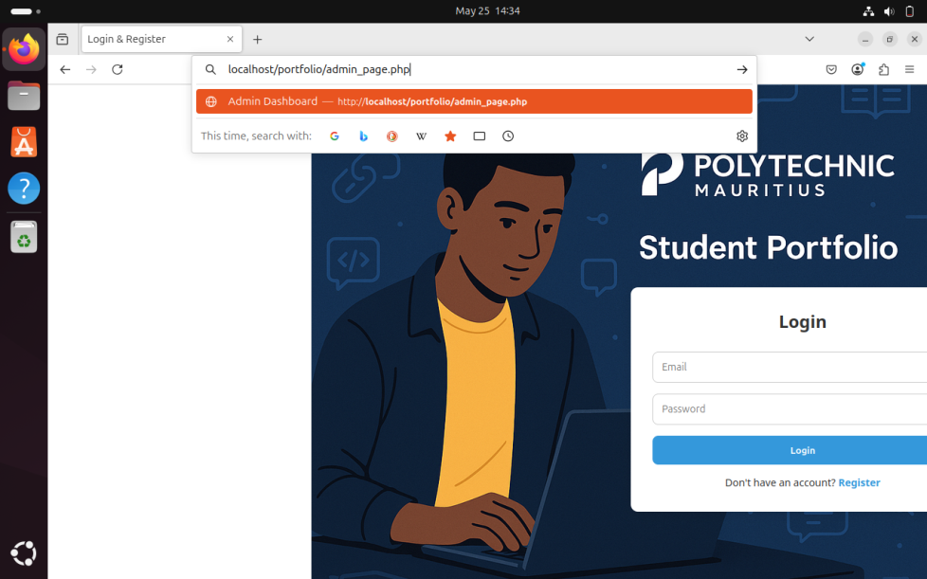

**Result: Access denied** – the page redirected or blocked access due to lack of session validation.

**Figure**: Screenshot showing the blocked forced browsing attempt.

**Summary of Protection Features**

|  |  |  |
| --- | --- | --- |
| Feature | Status | Protection Type |
| SQL Injection | Blocked ✅ | Prepared Statements (PHP) |
| Forced Browsing | Blocked ✅ | Session-based Access Control |

These implementations show that the website has basic but essential security controls against common web attacks.

# Task 6: Accessing the Website from Another Virtual Machine

After configuring the web server and firewall rules, I tested external access to ensure that the website could be accessed securely from a **different VM within the same network**.

**Step 1: Check Apache Service and Firewall Rules**

Before testing access from another machine, I made sure:

* Apache service was running:

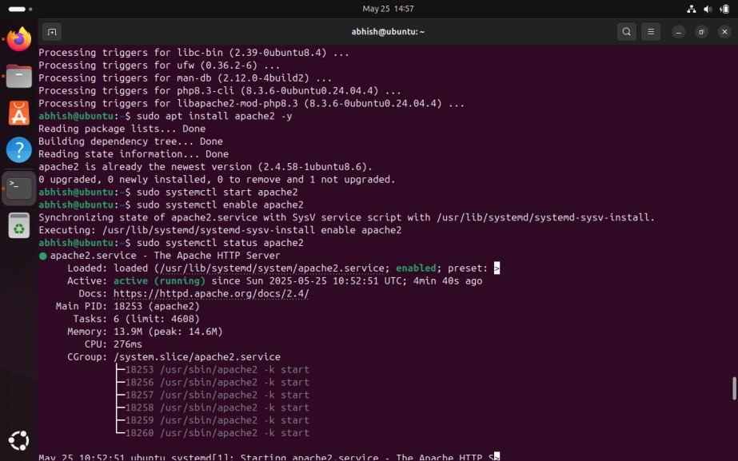

**Step 2: Get the Web Server’s IP Address**

On the hosting VM (Ubuntu server), I retrieved the internal IP address using:

……………………………….

**Step 3: Access the Website from Another VM**

On a second VM (client), I opened a browser and typed the server IP:

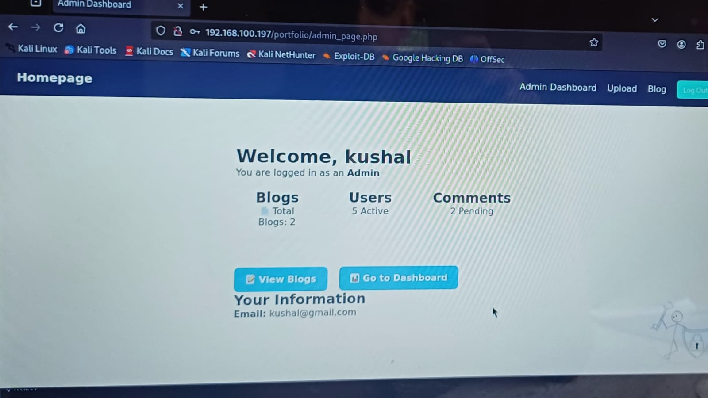

**Result**: The website loaded successfully, showing that the firewall, Apache configuration, and network settings were correctly applied.

**Figure**: Screenshot showing the website opened from a second VM.

**Summary**

|  |  |  |
| --- | --- | --- |
| Test | Result | Notes |
| Website accessible via HTTP | ✅ Success | Port 80 was open and Apache was running |
| Firewall configuration | ✅ Pass | Only allowed specific traffic (e.g., HTTP, SSH) |

# Conclusion

Throughout this project, I successfully deployed and secured a web server on Ubuntu by following essential best practices in secure website deployment, access control, firewall configuration, and monitoring.

🔒 **Key Achievements:**

* ✔️ Installed and configured Apache to host a portfolio website.
* ✔️ Properly set file permissions and ownership to restrict unauthorized access.
* ✔️ Implemented **Role-Based Access Control (RBAC)**, allowing users with different roles (admin/user) to access different pages securely.
* ✔️ Hardened the server using **iptables**, blocking all unnecessary traffic and allowing only essential ports such as 80 (HTTP) and 22 (SSH).
* ✔️ Successfully simulated and **prevented SQL injection and forced browsing** using prepared statements and access checks.
* ✔️ Confirmed secure and functional website access from another virtual machine in the network.
* ✔️ Monitored server status using **Zabbix**, ensuring ongoing visibility into system health and uptime.

This hands-on deployment reinforced my understanding of secure web hosting, Linux administration, and real-world cybersecurity defenses. It also demonstrated how practical configurations, such as proper user authentication, access restrictions, and firewall rules, can significantly improve the overall security posture of a system.